Data Visualisation Maria Konopka 16/02/2023

[Draw your reader in with an engaging abstract. It is typically a short summary of the document. When you’re ready to add your content, just click here and start typing.]

Contents

**Task 1** 2

**Task 2** 3

**Task 3** 11

# **Task 1**

**Policies and procedures**

When working with data, it's important to adhere to certain policies to ensure the privacy, security, and ethical use of that data. Here are some of the most important policies to consider:

1. Data privacy policy: This policy outlines how personal data will be collected, stored, processed, and shared, and how individuals can access, control, and delete their personal data.
2. Data security policy: This policy sets out the measures that will be taken to protect data from unauthorized access, disclosure, and theft, including encryption, access controls, and regular security assessments.
3. Data retention policy: This policy defines how long data will be stored, how it will be archived or deleted, and the criteria for determining when data is no longer needed.
4. Data quality policy: This policy establishes the standards for data accuracy, completeness, consistency, and relevance, and the processes for validating and correcting data.
5. Data access and sharing policy: This policy determines who has access to data, under what conditions, and for what purposes, and the procedures for sharing data with third parties.
6. Data ethics policy: This policy outlines the ethical principles that govern the collection, use, and sharing of data, and the processes for identifying and mitigating any ethical concerns.
7. Compliance policy: This policy ensures that data management practices are in line with legal, regulatory, and contractual obligations, such as GDPR, HIPAA, or PCI-DSS.

**Why these policies have to be adhered while using the data?**

* Adhering to these policies can help ensure that data is used responsibly and ethically, and that the risks associated with data management are minimized.

**Why is it important to be aware of these policies as a data analyst?**

Being aware of data policies is important for data analysts because it ensures legal compliance, addresses ethical considerations, provides guidelines for data security, and enables effective decision-making about data collection, analysis, and reporting. By adhering to data policies, data analysts can ensure that they are protecting personal information, maintaining trust with stakeholders, and avoiding legal and reputational risks. In summary, data policies help data analysts ensure that data is being collected, analyzed, and reported in a responsible and ethical manner.

# **Task 2**

Wealth of Nations Excel Analysis

1. Set a password to protect the workbook

To encrypt the workbook, I used “Protect Workbook” feature when navigating to the File -> Info section, another place where this option can be found is the Review Tab.

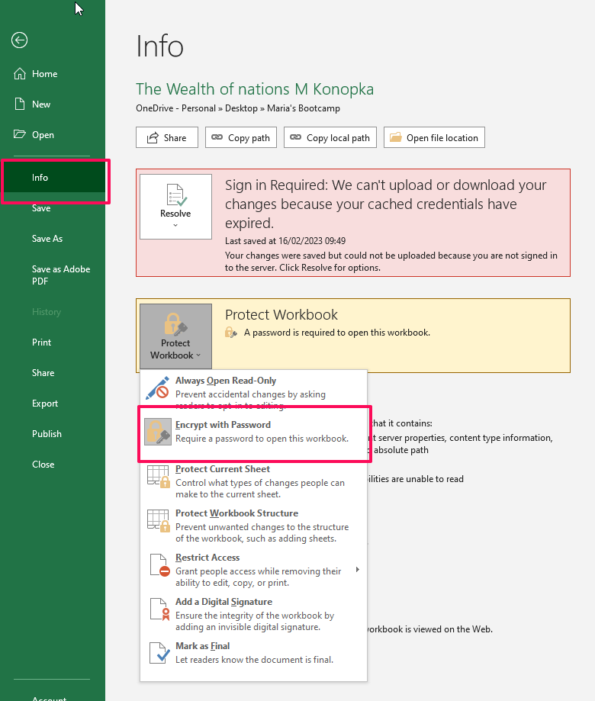

1. Highlight column C and change the data to display in British Pound symbol

Highlighted C column and used Currency format in format number section, changed the value to pounds.

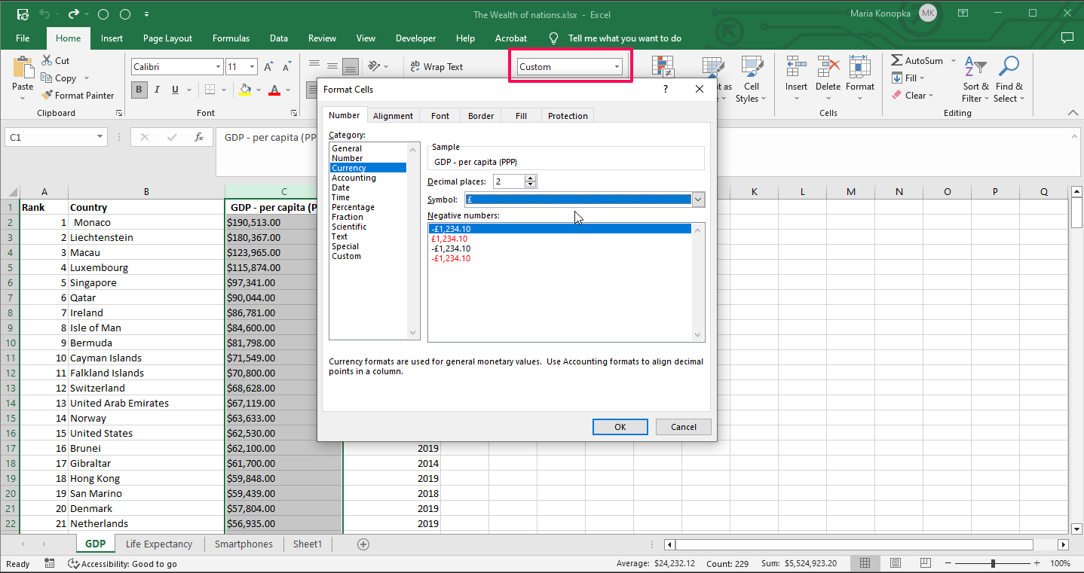

1. Turn the GDP sheet into a table

To change the data values into the table I highlighted all the data by using ctrl + A shortcut and then ctrl + T shortcut and chose the option “My table has headers”.

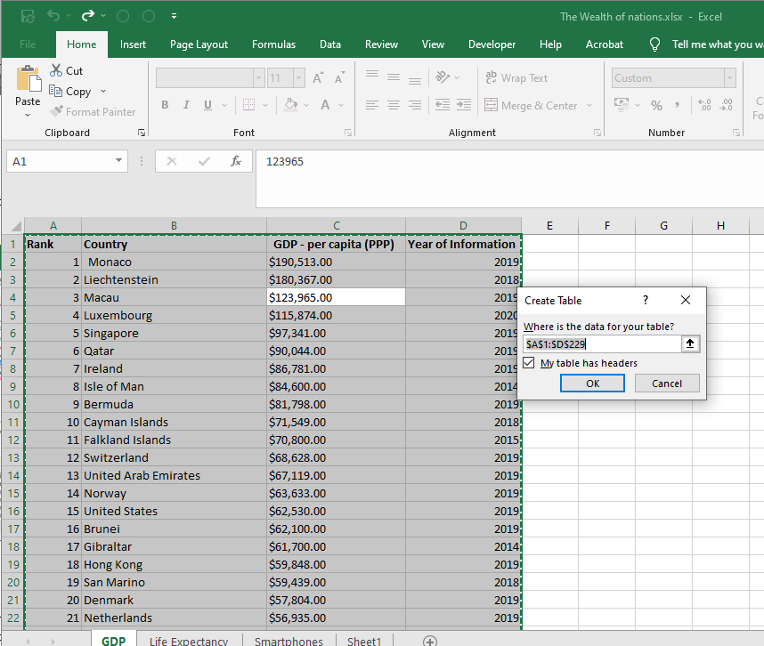

1. Filter the table to display year 2019 values only

To filter the data by year 2019 I left “ticked” only the value 2019 in Column D Year of Information. Another option to do that can be to choose the Number Filter and specify it to 2019

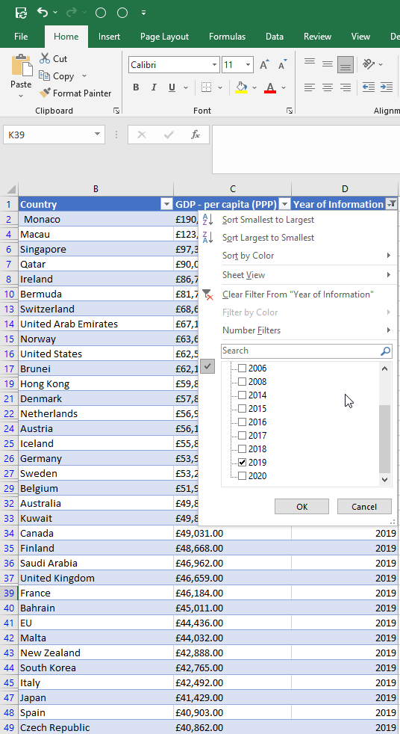

1. Create a chart that will only display the Rank, Country, and GDP – per capita (PPP) data.

For ease of filtering through the data I copied the relevant data from 2019 into the new tab. After that I highlighted the data and navigated to the Insert toolbar section, chose the Insert recommended chart. I chose the clustered columns chart.

1. Using your creative skills edit the chart

Added the title, axis labels, legend. Also I decided that would be better to have a combo chart with the rank displayed as a line and the GDP as columns. I right-clicked the chart, chose select data options and separated data series to Rank and GDP per capita. After that I changed the chart type to combo chart using Rank as a secondary Axis.

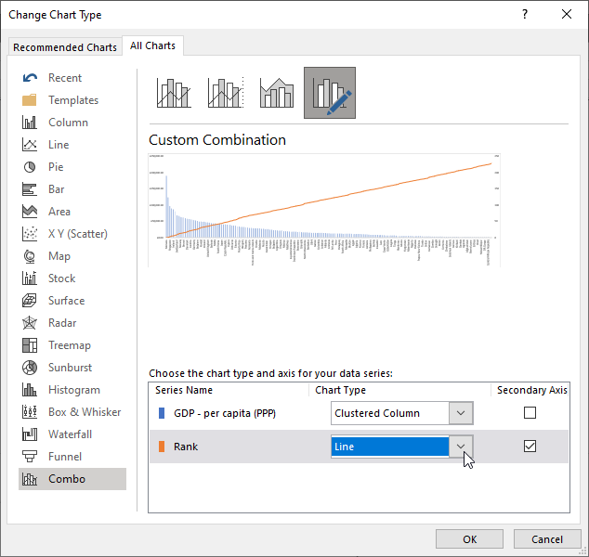

1. Move the chart to a new sheet tab and label with suitable name

Chart has been moved and tab renamed to GDP Chart 2019

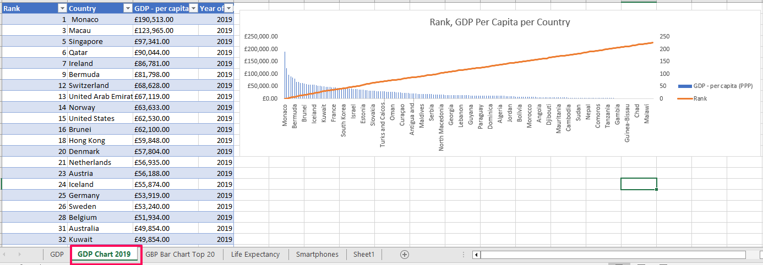

1. Create a sort for the top 20 highest ranking countries
2. Create a new Bar chart to display the 20 highest ranking countries from your sort and then move the chart to be underneath the table.
3. Colour the background by highlighting the area underneath the table as shown below. Find the add a fill colour icon and select a colour.

Used the filter sort option for Rank column, chose the numbers equal and smaller than 20.

Chart has been updated accordingly. Grey color selected as a background highlight for the area behind the chart.

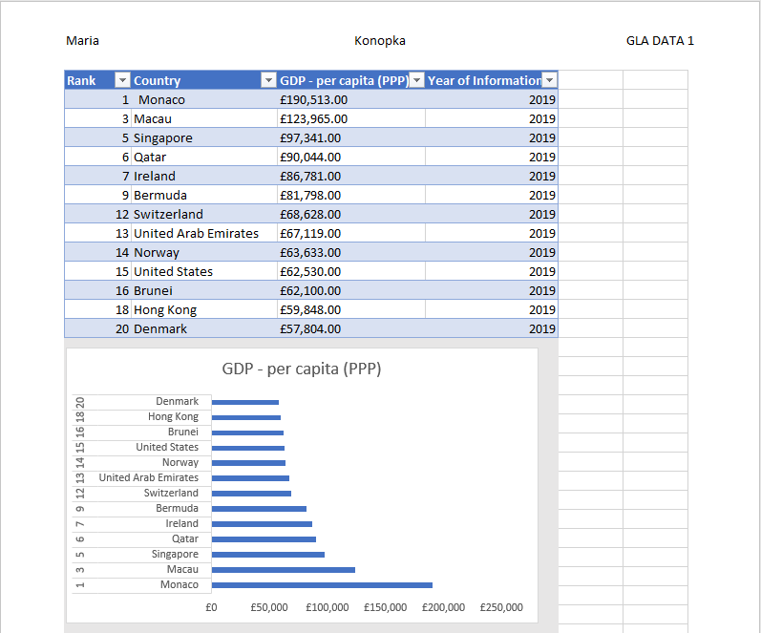

1. The next task is to create 3 macro buttons, print the sheet, Save the file and Copy the sheet.

First we need some icons for buttons which then can get macros assigned to them. I used Insert -> icons feature to get the buttons. After that I used Developer toolbar to record macros. All 3 of them worked as expected.

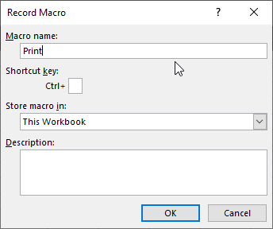

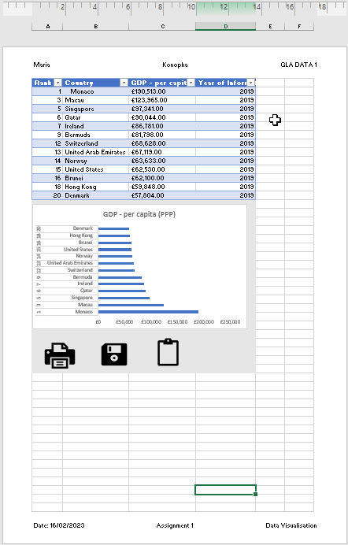

1. Using the copy macro, copy the sheet and then paste it into a new word document keeping the formatting. Give the page a title ‘GDP (Gross domestic product)’.
2. Save your document as ‘Word Gross domestic product report 1’

I Created new document and saved as ‘Word Gross domestic product report 1’ and title given ‘GDP (Gross domestic product)’.

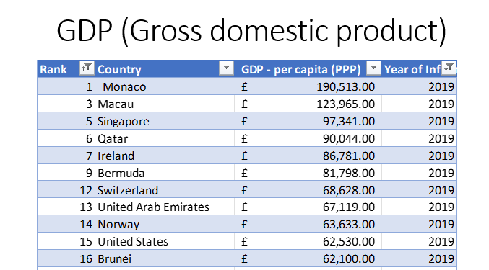

1. I used view toolbar to go page layout then I created header and footer

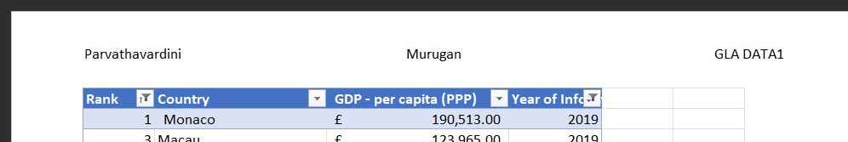

1. I edited all the columns to give details asked
2. I edited all the columns to give details asked
3. I edited all the columns to give details asked.



1. Saved table as ‘Excel Gross domestic product report 1’

# **Task 3**

1. Import Data
2. Set Relationships:

Data has been imported and given relationships in order.

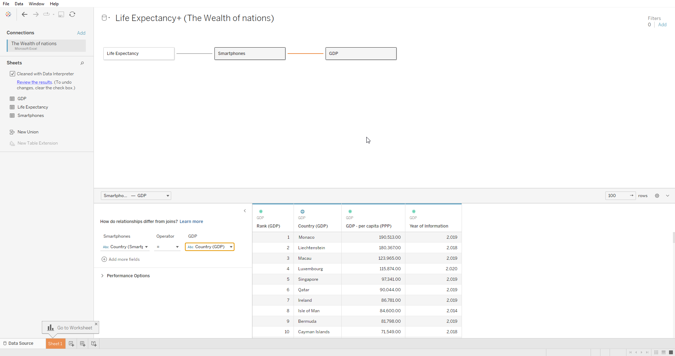

1. I built blind friendly charts for GDP, Life expectancy, Smartphones usages for Top 20 rank countries.

Dashboard with the statistics: https://public.tableau.com/app/profile/maria.konopka/viz/Asignment1_16765574795650/ASSIGNMENT1DASHBOARD?publish=yes

